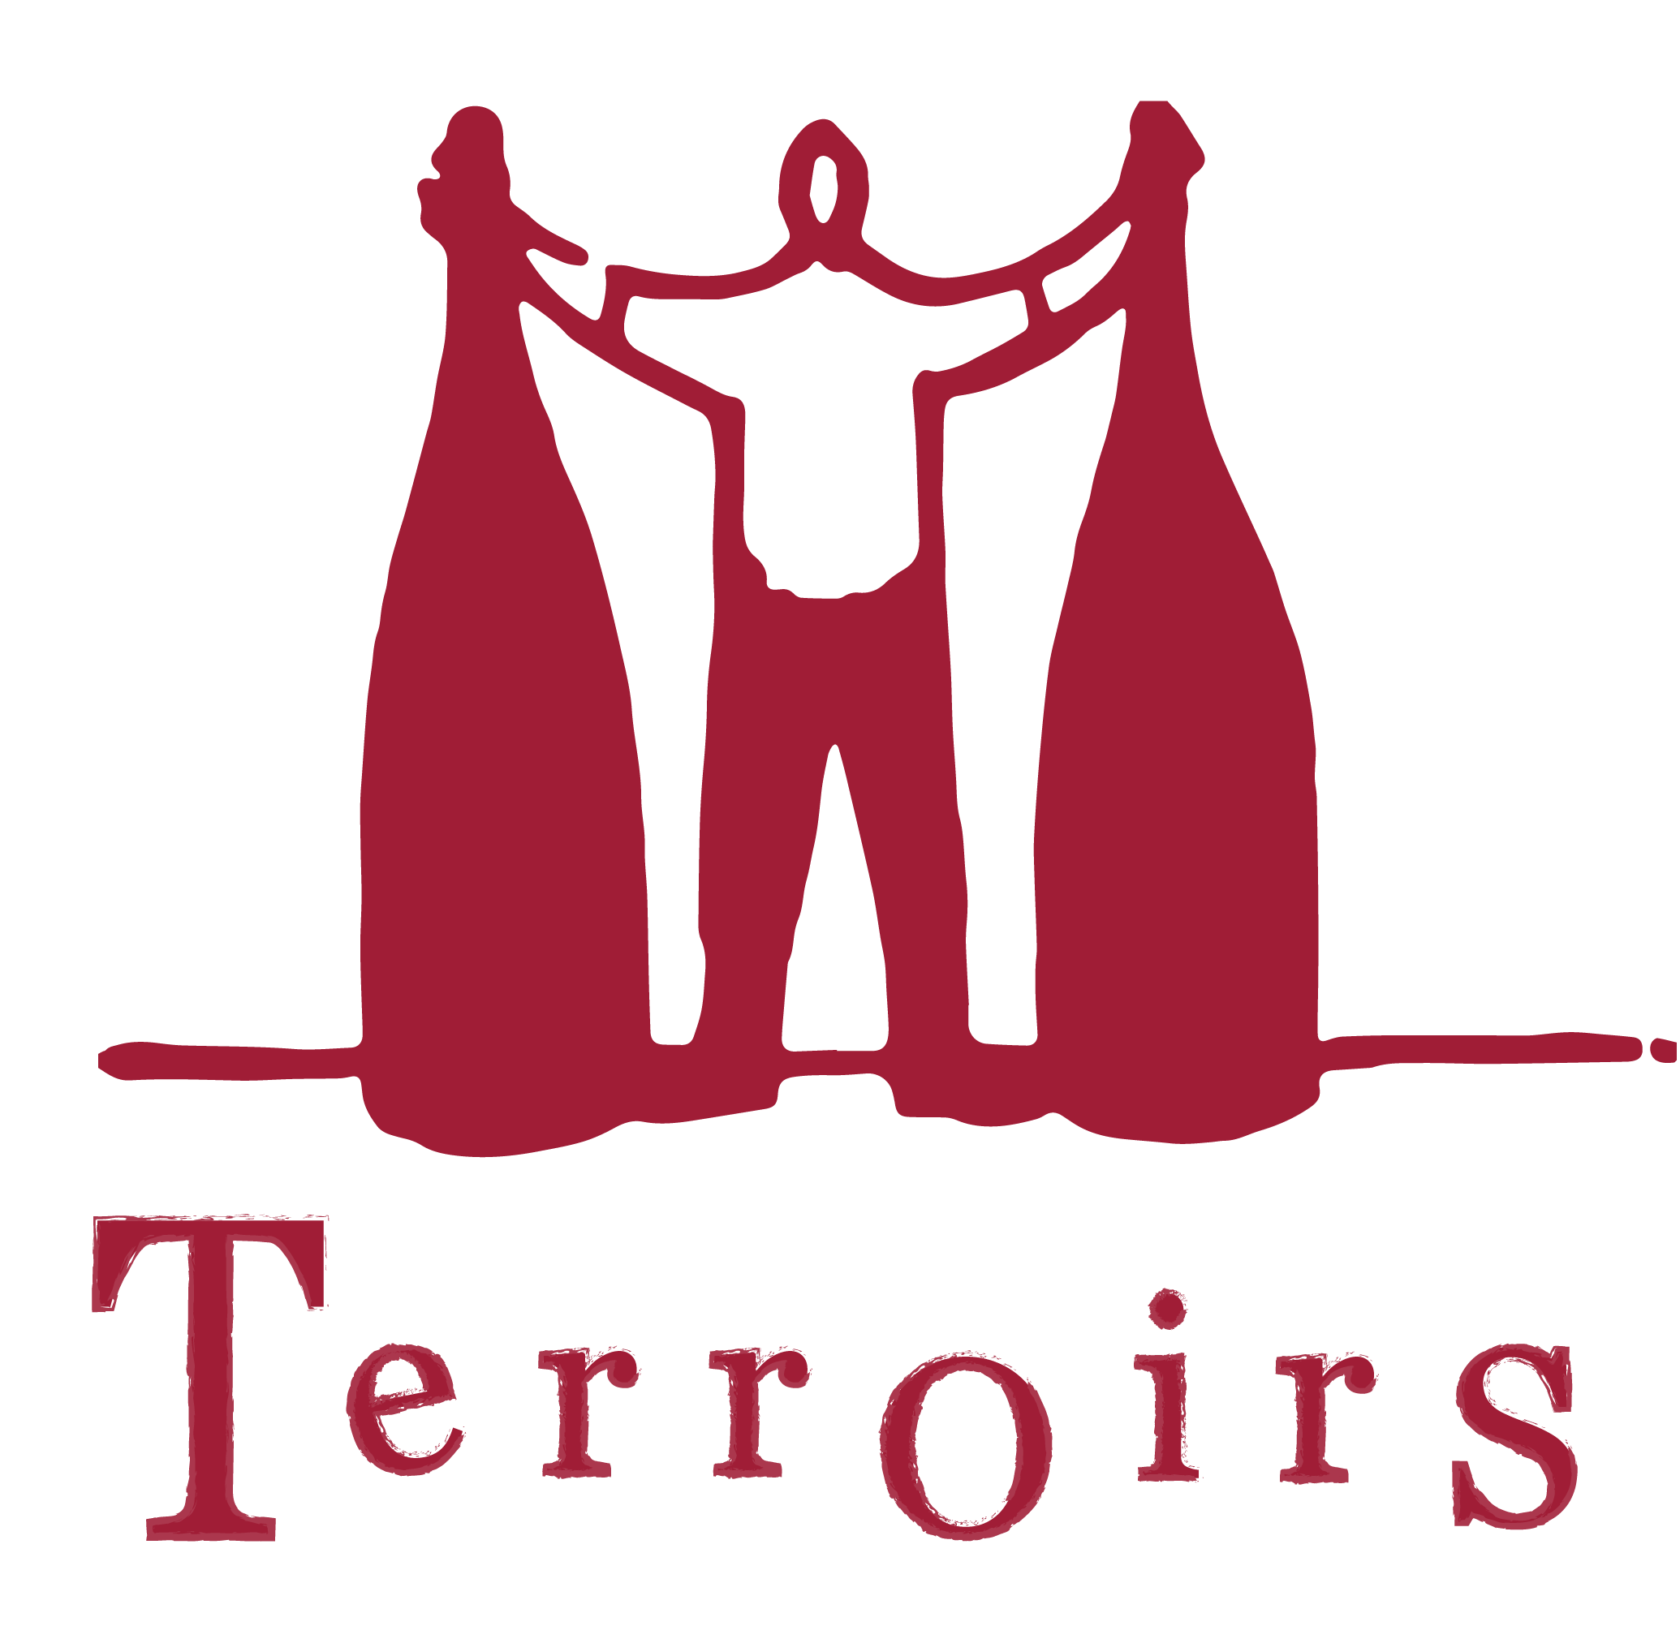

Vins de Terroirs
All our wines are sourced from small artisan growers who work sustainably, practicing organics or biodynamics in the vineyard. Much of the farming is labour-intensive, often done with horses rather than tractors and all of the picking and selection is done by hand. Yields, usually from old vines are low. Fermentations tend to be with wild yeasts; with most wines unfiltered and unfined and without the addition of sulphur dioxide and other additives.
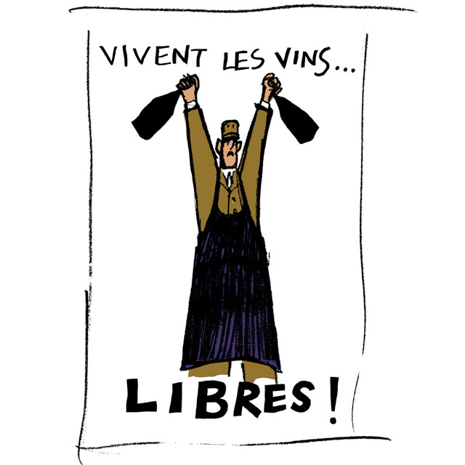

M.Tolmer

Below you can find a selection of winemakers who we feel really epitomise the meaning of terroir and produce wines that reflect the condition of the land and the fruit of every different vintage. Some may focus on a single grape, others a range of varietals and parcels across a region but they all trust in the purity of their fruit and it’s ability to produce real wine without the help of chemicals and other commercial processes.

Sparkling
Camillo Donati, Emilia-Romagna, Italy
2016 ”Malvasia Secco” Emilia-Romagna, Italy| Malvasia 32.00

Tillingham, Ben Walgate, East Sussex, England

2017 “PN” East Sussex, England | Dornfelder, Ortega, Pinot Noir 35.00
Casa Coste Piane, Veneto, Italy
NV ”Prosecco di Valdobbiadene DOCG” Veneto, Italy| Glera 37.50

La Biancara, Angiolino Maule, Veneto, Italy

2016 “Garg’N’Go“ Veneto, Italy | Garganega 38.00

Catherine & Pierre Breton, Bourgueil, Loire, France

NV “La Dilettante” Loire, France | Chenin Blanc 42.00
Quarticello, Emilia-Romagna, Italy
2016 ”Ferrando” Emilia-Romagna, Italy| Lambrusco Salomino 44.00
Dne Plageoles, Gaillac, South-West France
2016 ”Nature” Gaillac, France| Mauzac 44.00
Orsi San Vito, Federico Orsi, Emilia-Romagna, Italy
2016 ”Sui Lieviti” Emilia-Romagna, Italy| Pignoletto 45.00
1701, Franciacorta, Lombardy, Italy
NV ”SullErba” Lombardy, Italy| Chardonnay 45.00

Lise & Bertrand Jousset, Montlouis, Loire, France

2016 “Éxilé” Gaillac/Loire, France | Gamay 48.00

2015 “L’Appétillant” Montlouis, Loire, France | Chenin Blanc 52.00
Bodega Partida Creus, Catalunya, Spain
2016 “VN” Catalunya, Spain| Vinyate, Moscatel, Garnacha Blanca… 54.00
Jolly Ferriol, Roussillon, France
2016 “Pet’Nat” Roussillon, France | Muscat d’Alexandria, Muscat à Petit Grain 54.00

Jean-François Ganevat, Rotalier, Jura, France

2016 “La Combe” Jura, France | Chardonnay 56.00

Peggy & Jean-Pascal Buronfosse, Rotalier, Jura, France

2011 Extra Brut “Cremant” Jura, France | Savagnin 60.00
Lamiable, Ophélie & Orianne Lamiable, Tours-Sur-Marne, Champagne, France

NV Extra Brut “Grand Cru” Champagne, France | Pinot Noir, Chardonnay 70.00

Jacques Lassaigne, Montgueux, Aube, Champagne, France

NV Extra Brut “Les Vignes de Montgueux” | Pinot Noir, Pinot Blanc 95.00
Olivier Horiot, Les Riceys, Aube, Champagne, France

NV Extra Brut “Métisse” Champagne, France | Pinot Noir, Pinot Blanc 95.00
Vouette et Sorbée, Bertrand Gautherot, Aube, Champagne, France
NV ”Fidèle” Champagne, France| Pinot Noir 99.00
Demarne-Frison, Ville Sur Arce, Champagne, France
NV Blanc de Blancs « Lalore » | Chardonnay 105.00

White - Loire
Dne Luneau Papin, Muscadet
2016 “Folle Blanche“| Folle Blanche 24.00
Pierre-Olivier Bonhomme, Touraine
2016 “Blanc” Touraine, Loire, France | Sauvignon Blanc 32.50
2015 “La Tesnière” | Menu Pineau, Romorantin 46.50
Clos du Tue-Boeuf, Jean-Marie & Thierry Puzelat, Touraine
2017 “P’tit Blanc” | Sauvignon Blanc (from tap) 37.50
2016 Cheverny “Frileuse” | Sauvignon Blanc, Fié Gris, Chardonnay 42.00
2015 “Buisson Pouilleux” | Sauvignon Blanc 48.00
Dne Les Cailloux du Paradis, Claude & Etienne Courtois, Touraine
2015 “Quartz” | Sauvignon Blanc 54.00
2015 “Plume d’Ange” | Sauvignon Blanc 55.00
2013 “Racines” | Sauvignon Blanc, Menu Pineau, Romorantin, Chardonnay 57.00
2013 “Romorantin” | Romorantin 69.00
2011 “Or’Norm” | Sauvignon Blanc 51.50
Sebastian Riffault, Sancerre
2014 “Les Quarterons” Sancerre, Loire, France| Sauvignon Blanc 56.00
Alexandre Bain, Pouilly-Fumé
2015 “Pierre Precieuse“ | Sauvignon Blanc 59.00
Hervé Villemade, Cour-Cheverny
2012 “Les Acacias“ | Romorantin 57.00
Lise & Bertrand Jousset, Montlouis-sur-Loire
2015 “Premier Rendez-Vous” | Chenin Blanc 60.00
L’Ange Vin, Jean-Pierre Robinot, Jasnières
2008 “Le Charme du Loir” | Chenin Blanc 65.00
2004 “Cuvée Juliette” | Chenin Blanc 130.00
2003 “Les 4 Vents” | Chenin Blanc 105.00
Dne La Coulée d’Ambrosia, Jean-François Chéné, Anjou
2011 “L’O2 Voile” | Chenin Blanc 61.00
2008 “Jardin de Chiron” | Chenin Blanc 64.00
Dne Le Batossay, Baptiste Cousin, Anjou
2015 “Pied” | Chenin Blanc 56.00
Benoit Courault, Faye d’Anjou
2015 “Gilbourg” | Chenin Blanc 53.50
2013 “Les Guinechiens” | Chenin Blanc 62.00
Dne Agnès & René Mosse, Anjou
2015 “Blanc” Anjou, Loire, France | Chenin Blanc 47.50
2013 “Initials BB” | Chenin Blanc 70.00
La Grapperie, Renaud Guettier, Coteaux du Loir
2014 “Desirée” Loire, France | Chenin Blanc 79.00

White – Burgundy & Beaujolais
Dne Vini Viti Vinci, Nicolas Vauthier, Avallon, Burgundy
2015 “Breau” | Aligoté 43.00
2015 Chanvan “Coulanges la Vineuse” | Aligoté 46.50
Le Vendangeur Masqué, Alice & Olivier de Moor, Chablis, Burgundy
2015 Chablis “L’Humeur Du Temps” | Chardonnay 57.00
2015 “Chitry” | Chardonnay 52.00
2015 “Bourgogne Aligoté” | Aligoté 42.00
Uliz, Antoine Petitprez, Beaune
2014 1er Cru “Le Val” Auxey-Duresses | Chardonnay 89.00
Le Grappin, Andrew & Emma Nielsen, Beaune
2015 Saint Aubin « En L’Ebaupin » | Chardonnay 86.00
Dne Catherine et Dominique Derain, Saint-Aubin
2014 Saint-Aubin « La Combe » | Chardonnay 69.00
Sextant, Julien Altaber, Saint-Aubin
2016 Bourgogne “Fleur Au Verre”|Chardonnay 67.00
2016 “Bourgogne Aligoté” | Aligoté 59.00
Phillipe Valette, Mâcon-Chaintré
2012 “Pouilly-Fuissé” | Chardonnay 80.00
Dne Sauveterre, Jérôme Guichard, Mâcon
2015 “Vin d’Montbled” | Chardonnay 60.00
Dne de Botheland, Rémi et Laurence Dufraitre, Beaujolais
2016 “Le Blanc” Beaujolais, France | Chardonnay 45.00

White - Alsace
Les Vins Pirouettes, Binner et Compagnie, Ammerschwihr
2015 “Les Saveurs de Julien” Alsace, France| Auxerrois, Sylvaner 32.50
Dne Gérard Schueller, Husseren-Les-Châteaux, Alsace
2015 “Cuvée H” | Pinot Blanc 47.50
2014 “Bildstoecklé” | Riesling 56.50
2010 “Grand Cru Pfersigberg” | Riesling 90.00
2006 “Bildstoecklé” | Riesling 70.00
2000 “Bildstoecklé Réserve TS” | Gewürztraminer 120.00
Dne Pierre Frick, Pfaffenheim, Alsace
2016 “Sans Soufre Ajouté” | Chasselas 36.50
2016 “Grand Cru Vorbourg Macération” | Pinot Gris 58.00
2015 “Bihl” | Riesling 42.50
2014 “Sans Soufre Ajouté” | Pinot Gris 47.00
2008 “Bergweingarten” | Sylvaner 45.00
2002 “Rot Murlé” | Riesling 48.00

White – Jura
Dne Les Cavarodes, Etienne Thiebaud, Cramans, Côtes-du-Jura
2015 “Lumachelles” | Chardonnay 39.00
Dne de l’Octavin, Alice Bouvot, Arbois
2016 “P’tit Poussot” | Chardonnay 66.00
Didier Grappe, Arbois
2015 “Ouillé”| Traminer 62.50
Dne Bottes Rouge, Jean-Baptiste Menigoz, Arbois, Jura
2014 “Léon” | Chardonnay 61.00
2016 “No Milk Today” | Savagnin 75.00
Dne Pierre Overnoy, Emmanuel Houillon, Arbois-Pupillin, Jura
2012 “Arbois-Pupillin” | Savagnin 95.00
Renaud Bruyere & Adeline Houillon, Arbois-Pupillin, Jura
2014 “Savagnin” | Savagnin 85.00
2014 “La Croix Rouge” | Chardonnay 85.00
Marie-Pierre Chevassu, Château-Chalon
2015 “Sous-Voile” | Chardonnay 38.00
Les Dolomies, Céline & Steve Gormally, Passenans
2016 “La Chaux” | Chardonnay 61.00
Anne & Jean-François Ganevat, Rotalier, Jura
2014 “Florine” | Chardonnay 68.00
2014 “Grusse en Billat” | Chardonnay 66.00
2014 “Les Grandes Teppes Vieilles Vignes” | Chardonnay 80.00
2013 “Les Grandes Teppes Vieilles Vignes” | Chardonnay 70.00
2013 VdF “Le Zaune à Dédée” | Savagnin, Gewürztraminer (sk/ox) 73.00
2014 “Les Chalasses Marnes Bleues” | Savagnin 85.00
2012 “Les Chalasses Marnes Bleues” | Savagnin 75.00
2012 “Dolium” | Chardonnay (sk/ox) 62.00
2011 “Cuvée de Garde” | Chardonnay, Savagnin (ox) 69.00
2010 “Cuvée de Garde” | Chardonnay, Savagnin (ox) 60.00
2008 “La Cuvée du Pepe” | Chardonnay (ox) 120.00
2008 “Cuvée Prestige” | Savagnin (ox) 88.00
2006 “Cuvée Prestige” | Savagnin (ox) 79.00
Peggy & Jean-Pascal Burenfosse, Rotalier, Jura
2014 “Le Varron” | Chardonnay 55.00
2014 “Le Varron” | Savagnin (ox) 55.00
2014 “Les Ammonites” | Chardonnay 49.00
2014 “Marcus Terentius Varro” | Chardonnay 42.00
2013 “L’Hopital” | Savagnin 58.00
2012 “Et Entre Deux” | Savagnin Vert & Gris 58.00

White –Savoie

Dne Giachino, Chartreuse, Savoie
2014 “Monfarina” | Jacquère 40.00
Dne Belluard, Ayse, Savoie
2015 “Les Alpes” | Gringet 69.00
2014 “Grandes Jorasses” | Altesse 61.00
Gilles Berlioz, Chignin, Savoie
2014 “El…Hem”| Altesse 65.00
Jean-Yves Péron, Chignin, Savoie
2015 “La Petite Robe” | Jacquère 61.00
2015 “La Bottière” | Jacquère 73.00
2015 “La Grande Journée” | Altesse 79.00
2015 “Côtillon des Dames” | Jacquère , Altesse 69.00
2014 “Côtillon des Dames” | Jacquère , Altesse 74.00
2014 “Les Barrieux” | Jacquère , Altesse, Roussanne 83.00

White – Rhône

Dard et Ribo, René-Jean Dard & François Ribo, Mercurol
2016 St Joseph “Blanc” | Marsanne 75.00
2016 St Joseph “Pitrou” | Marsanne 89.00
2016 Hermitage “Blanc” | Roussanne 135.00
Grégory Guillaume, Ardèche
2016 VDF “Lou Coulego” | Chardonnay 46.50
Daniel Sage, Ardèche
2016 “La Voix du Périscope”| Viognier 63.00
Dne Viret, Philippe Viret, Saint-Maurice-sur-Eygues
2015 “Dolia Paradis Ambré” | Muscat, Bourboulenc, Clairette, Roussanne 85.00

White – Languedoc-Roussillon & South-West

Laurent Cazottes, Gaillac
2016 “Marcotte” | Mauzac Blanc (from tap) 28.50
Dne Nicolas Carmarans, Aveyron
2015 “Selves” | Chenin Blanc 54.00
La Sorga, Anthony Tortul, Aude-Herault
2016 “French Wine’s Not Dead” | Terret Bourret, Mauzac Blanc, Clairette 44.00
Dne Leon Barral, Didier Barral, Faugères
2013 VDP de l’Herault “Blanc” | Terret Gris, Terret Blanc, Viognier, Roussanne 60.00
Jolly Ferriol, Isabelle Jolly & Jean-Luc Chossart, Côtes Catalanes
2016 “M” | Muscat d’Alexandria 54.00
Le Soula, Wendy Paillé, Les Fenouillèdes, Côtes Catalanes
2009 “Blanc” | Sauvignon, Macabeu, Grenache Blanc, Rolle 67.00

White – Northern Italy & Slovenia
Cascina degli Ulivi, Stefano Bellotti, Piedmont
2015 “Semplicemente” | Cortese 35.00
AA Elisabetta Foradori, Trentino
2015 Vigneti Delle Dolomiti IGT “Fontanasanta”| Nosiola 69.50
Filippo Filippi, Veneto
2015 “Turbiana” | Trebbiano 45.00
Skerlj, Matej Skerlj, Carso, Friuli
2013 “Vitovska” | Vitovska 74.00
JNK, Kristina Mervič, Sempas, Slovenia
2012 “Malvazija” | Malvasia 61.00

White – Central Italy
Fattoria San Lorenzo, Natalino Crognaletti, Marche
2016 Verdicchio dei Castelli di Jesi “Di Gino”| Verdicchio 27.00
2004 IGT “Marche Bianco” | Verdicchio 105.00
La Distesa, Corrado Dottori, Marche
2015 “Gli Eremi” | Verdicchio 67.00
Le Coste, Gianmarco Antonuzzi, Gradoli, Lazio
2015 “Bianchetto” | Procanico, Malvasia, Moscato 52.50
Massa Vecchia, Maremma, Francesca Sfrondrini, Tuscany
2015 “Ariento” | Vermentino 78.00
Azienda Agricola Valentini, Abruzzo
2013 “Trebbiano d’Abruzzo” | Trebbiano d’Abruzzo 135.00

White – Southern Italy & Sicily
Cantina Giardino, Antonio & Daniela De Gruttola, Campania
2016 “Paski” | Coda di Volpe 58.00
2016 “T’ara’ra” | Greco 61.00
2016 “Sophia” | Fiano 63.50
2016 “Tu Tu” | Fiano 67.50
2015 “Adam” | Greco 68.50
Nino Barraco, Sicily
2016 “Catarratto” | Catarratto 57.00
2015 “Zibibbo” | Zibibbo 59.00
I Vigneri, Salvio Foti, Sicily
2014 “Vigna di Milo” | Carricante 64.00

White – Spain & Portugal
Cellar Credo, Penèdes, Spain
2014 “Aloers” | Xarel.lo 37.50
Bodega Partida Creus, Antonela Gerosa & Massimo Marchiori, Tarragona, Spain
2016 “VN” | Vinyate, Moscatel, Garnacha Blanca, Panset, Macabeo, Xarel.lo 38.50
Bernabe Navarro, Alicante, Spain
2015 “El Carro” | Moscatel 32.50
Aphros, Vasco Croft, Lima, Portugal
2015 “Vinho Verde” | Moscatel 32.50

White – Austria, Hungary & Germany
Anna & Martin Arndorfer
2016 “Handcrafted“ Kamptal, Austria | Grüner Veltliner 29.00
Maria & Sepp Muster, Styria, Austria
2015 “Opok” | Welschriesling, Gelber Muskateller, Sauvignon, Morillon 44.50
Meinklang, Niklas Peltzer, Burgenland-Sómlo, Austria-Hungary
2013 Sómlo “J13” | Juhfark 70.00
Weingut Brand, Jonas & Daniel Brand, Pfälz
2016 “Pur” | Pinot Blanc 52.00

White – New World
Testalonga, Craig Hawkins, Swartland, South Africa
2017 “Stay Brave” | Chenin Blanc 32.00
Gentle Folk, Gareth Belton, Adelaide Hills, Australia
2016 “Chardonnay” | Chardonnay 50.00
Xavier Goodridge, Victoria, Australia
2016 “Halfway to Heaven” | Fiano 49.00
Momento Mori Wines, Dane Johns, Victoria, Australia
2016 “Staring At The Sun” | Vermentino, Fiano, Malvasia, Moscato Giallo 60.00
Felton Road, Central Otago, New Zealand
2015 “Dry” | Riesling 60.00
Bow & Arrow, Scott & Dana Frank, Portland, USA
2015 “Melon” | Melon de Bourgogne 49.00

Skin Contact Whites
Bernabe Navarro, Rafa Bernabe, Alicante, Spain
2015 “Tinajas Benimaquía” | Moscatel 32.50
Olivier Lemasson, Cheverny, Loire, France
2015 “Indigène” | Menu Pineau, Meslier, Baco Blanc, Gaillard 34.00
La Biancara, Angiolino Maule, Veneto, Italy
2015 “Sassaia” Veneto, Italy| Garganega 36.00
Denavolo, Emilia-Romagna, Italy
2015 “Dinavolino” | Malvasia di Candia, Ortrugo, Marsanne 38.00
Pheasant’s Tears, John Wurdeman, Kakheti, Georgia
2015 “Rkatsiteli Bodbiskhevi” | Rkatsiteli 40.00
Podere Santa Maria, Marino Colleonis, Montalcino, Tuscany, Italy
2016 “Bianco” | Ansonica 47.50
Tenuta Grillo, Guido Zampaglione, Monferrato, Piedmont
2009 “Baccabianco” | Cortese 51.00
Sebastian Riffault, Sancerre, Loire, France
2012 “Auksinis” | Sauvignon Blanc 70.00
Dario Princic, Friuli-Venezia, Italy
2013 “Jakot“| Friulano 75.00
Gabrio Bini, Pantelleria, Italy
2015 “Serragghia 19 Months Skin Contact“| Zibbibo 99.00

Pink
Bernabe Navarro, Rafa Bernabe, Alicante, Spain
2016 “Musikanto” Alicante, Spain| Garnacha 34.00
Dne Les Terres Promises, Jean-Christophe Comor, Provence, France
2016 “L’Apostrophe” Provence, France| Grenache, Cinsault, Carignan 35.00
Franz Strohmeier, Styria, Austria
2013 “Schilcher No.25” | Blauer Wildbacher 38.00
Catherine Bernard, Languedoc, France
2016 “Le Rosé” | Carignan 40.00
Dne Mouressipe, Alain Allier, Gard, France
2016 “Galejade” | Cinsault, Grenache 40.00
Podera Santa Maria, Marino Colleonis, Montalcino, Tuscany, Italy
2016 “Rosato” | Sangiovese 45.00
L’Anglore, Eric Pfifferling, Gard, France
2015 “Tavel” | Grenache 47.50
Marco Buratti, Colli Euganei, Veneto, Italy
2016 “All-In” | Moscato, Malvasia, Friulano, Merlot, Cabernet, Pataresca… (1L)56.00
Dne Tempier, Bandol, Provence, France
2016 “Rosé“| Grenache, Cinsault, Carignan, Mouvèdre 65.00
Christian Tschida, Burgenland, Austria
2016 “Himmel Auf Erden“| Cabernet Franc 66.00

Red - Loire
Clos du Tue-Boeuf, Jean-Marie & Thierry Puzelat, Touraine, Loire Valley
2017 “Vin Rouge“ | Gamay (from tap) 34.00
2014 “La Guerrierie Qvevri “ | Côt, Gamay 60.00
2013 Cheverny “La Caillère“ | Pinot Noir 46.00
Dne Les Cailloux du Paradis, Claude & Etienne Courtois, Touraine, Loire Valley
2014 “L’Icaunais” | Gascon 62.00
2013 “Racines” | Cabernet Franc, Cabernet Sauvignon, Côt 57.00
2012 “Etourneaux” | Gamay 51.00
L’Ange Vin, Jean-Pierre Robinot, Jasnières, Loire Valley
2016 “Le Regard” | Pineau d’Aunis 77.50
2014 “Lumière des Sens” | Pineau d’Aunis 69.50
Dne Catherine et Pierre Breton, Bourgueil
2016 “Grolleau” | Grolleau 39.00
2012 Bourgueil “Perrières” | Cabernet Franc 61.00
1999 Chinon “Beaumont” | Cabernet Franc 99.00

Les Roches Sèches, Julien Delrieu, Thibault Ducleux & Jean-Marie Brousset, Anjou 2015 “Les Essards” | Grolleau 39.50
Benoit Courault, Faye d’Anjou
2015 “La Coulée” | Grolleau 42.00
Olivier Cousin, Anjou
2015 “PUR Breton” | Cabernet Franc 40.00
Dne Le Batossay, Baptiste Cousin, Anjou
2016 “Ouech’Cousin” | Grolleau 50.00
2015 “Dynamitage” | Gamay 48.00
Dne La Coulée d’Ambrosia, Jean-François Chéné, Anjou
2014 “Le Boit Sans Soif” | Grolleau 35.00
Jérôme Lambert, Anjou
2015 “Le Fil Rouge” | Grolleau, Cabernet Franc 52.50

Stéphanie & Vincent Deboutbertin, Anjou
2015 “Baliverne” | Grolleau 56.50
Les Vignes de Babass, Anjou
2015 “Groll’n Roll” | Grolleau 46.00
La Grapperie, Renaud Guettier, Coteaux du Loir
2011 “Le Gravot” | Gamay, Grolleau, Côt, Pineau d’Aunis 48.00

Red - Auvergne
No Control, Vincent Marie, Volvic
2016 “Fusion” Auvergne, France | Gamay d’Auvergne 51.00
Vincent & Marie Tricot, Orcet
2016 ”Les Milans” Auvergne, France| Pinot Noir, Gamay 57.00

Red – Jura & Savoie
Dne Les Cavarodes, Etienne Thiebaud, Cramans, Côtes-du-Jura

2016 “Rouge VdF” Jura, France| Pinot Noir, Trousseau, Poulsard, Enfariné… 39.50
Dne François Rousset-Martin, Nevy-sur-Seille, Côtes-du-Jura
2015 ”VdF” Côtes-du-Jura, France| Pinot Noir 58.00
Dne de l’Octavin, Alice Bouvot, Arbois
2016 “Trousseau des Corvées” | Trousseau 71.00
Frédéric Cossard, Saint Romain, Burgundy (grapes from Rotalier, Jura)
2016 “Vin du Jura” | Pinot Noir 64.00
Dne Bottes Rouge, Jean-Baptiste Menigoz, Arbois, Jura
2015 “Tôt ou Tard” | Ploussard 57.50
2014 “C’est Max” | Pinot Noir 61.00
Renaud Bruyere & Adeline Houillon, Arbois-Pupillin, Jura
2016 “Ploussard” | Ploussard 75.00
2015 “Ploussard” | Ploussard 85.00
Dne Pierre Overnoy, Emmanuel Houillon, Arbois-Pupillin, Jura
2015 “Arbois-Pupillin” | Ploussard 90.00
Anne & Jean-François Ganevat, Rotalier, Jura
2016 “En Billat” | Pinot Noir 85.00
2015 “En Billat” | Pinot Noir 80.00
2016 “Cuvée Julien” | Pinot Noir 89.00
2015 “Cuvée Julien” | Pinot Noir 85.00
2016 “Cuvée de l’enfant Terrible” | Poulsard 70.00
2016 VdF “Seau-Trou les Corvées” | Trousseau 68.00
Peggy & Jean-Pascal Burenfosse, Rotalier, Jura
2015 “Sous Le Monceau” | Poulsard 58.00
2012 “Les Fontaines” | Pinot Noir 54.00
Gilles Berlioz, Chignin, Savoie
2014 “La Deuse” Savoie, France | Mondeuse 68.00
Dne Belluard, Ayse, Savoie
2014 “Amphora” | Mondeuse 65.00
Jean-Yves Péron, Chignin, Savoie
2015 “Vers la Maison Rouge” | Mondeuse, Gamay 61.00
2015 “Côte Pelée” | Mondeuse 73.00
2014 “Le Pas de l’Ours” | Mondeuse 83.00
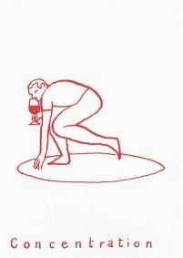

Red – Alsace
Christian Binner, Ammerschwihr
2014 ” Cuvée Béatrice ” Alsace, France| Pinot Noir 56.00
Dne Gérard Schueller, Husseren-Les-Châteaux, Alsace
2016 “Pinot Noir” | Pinot Noir 51.50
2014 “LN” | Pinot Noir 64.50
Dne Pierre Frick, Pfaffenheim, Alsace
2016 “Rot Murlé” | Pinot Noir 56.00

Red – Burgundy
Dne Vini Viti Vinci, Nicolas Vauthier, Avallon, Burgundy
2014 Irancy “Les Mazelots” | Pinot Noir 68.00
2013 Irancy “Rouge Generique” | Pinot Noir 50.00
Michel Lafarge, Volnay, Côte de Beaune
2011 “Côtes de Beaune Villages” Burgundy, France| Pinot Noir 69.00
Le Grappin, Andrew & Emma Nielsen, Beaune
2015 “Savigny-Les- Beaune” | Pinot Noir 79.00
Uliz, Antoine Petitprez, Beaune
2014 Côte de Nuits Villages “Le Montagne” | Pinot Noir 78.00
2014 Santenay “Clos des Cornières” | Pinot Noir 71.00
Dne Les Vignes de Paradis, Dominique Lucas, Beaune
2015 “Nectar de Pinot Noir” | Pinot Noir 80.00
Sextant, Julien Altaber, Saint-Aubin, Burgundy
2016 “Coteaux Bourguignons”|Pinot Noir, Gamay 57.00
2016 Bourgogne “Fleur Au Verre”|Pinot Noir 60.00
Dne Sauveterre, Jérôme Guichard, Mâcon
2017 “Jus de Chausette” | Gamay 46.00

Red – Beaujolais

Rémi et Laurence Dufraitre

2017 “Gamay de France” Beaujolais, France | Gamay (from the tap) 28.50
Dne Jean-Claude Lapalu, Brouilly
2016 Brouilly “Vieilles Vignes” | Gamay 47.00
Michel Guignier, Vauxrenard
2014 “Granite”| Gamay 52.50
Jean-Louis Dutraive, Fleurie
2016 ”Fleurie”| Gamay 63.00
Julie Balagny, Moulin-à-Vent
2016 Fleurie “Cayenne” | Gamay 66.00
2016 Moulin-à-Vent “Docteur Buchaille” | Gamay 75.00
Karim Vionnet, Morgon
2016 “Du Beur dans les Pinards” | Gamay 45.00

Red – Northern Rhône
Dne Stéphane Othéguy, Côte-Rôtie
2012 Saint-Joseph “Le Temps des Cerises” | Syrah 68.50
Dard et Ribo, René-Jean Dard & François Ribo, Mercurol
2016 Crozes-Hermitage “C’est Le Printemps” | Syrah 50.00
2016 St Joseph “Rouge” | Syrah 75.00
2016 St Joseph “Pitrou” | Syrah 85.00
2016 Hermitage “Rouge” | Syrah 125.00

Red – Ardèche, Southern Rhône & Provence
Dne des Vigneaux, Valvignères, Ardèche
2016 “Syrah II” Ardèche, France| Syrah 28.00
2015 “Du Bout des Doigts” Ardèche, France| Pinot Noir 30.00
Jérôme Jouret, Villeneuve de Berg, Ardèche
2016 “La Coulée Douce” Ardèche, France| Syrah 37.50
2015 “Pas a Pas” Ardèche, France| Grenache, Syrah, Alicante 35.00
Andrea Calek, Alba La Romaine, Ardèche
2016 “A Toi Nous” Ardèche, France| Grenache 38.00
Dne Romaneaux-Destezet, Beatrice & Hervé Souhaut, Ardèche (Négoce)
2016 “La Souteronne” | Gamay 51.00
2016 “VDP de l’Ardèche” | Syrah 49.00

Les Vignerons d’Estézargues, Côtes-du-Rhône

2016 “Les Galets“ | Syrah, Grenache (from the tap) 24.00
Dne Gramenon, Michele Aubrey-Laurent, Côtes-du-Rhone
2016 “Poignée de Raisins” | Grenache 37.50
Dne Mouressipe, Alain Allier, Gard
2013 “Galapia” Gard, France| Mourvèdre 45.00
Pascal Chalon, Tuilette, Côtes-du-Rhone
2015 “Le Petite Ourse” | Grenache, Syrah 46.00
Dne Viret, Philippe Viret, Saint-Maurice-sur-Eygues
2014 “Renaissance” Rhône, France | Grenache, Syrah, Mourvèdre 54.00
Villeneuve, Châteauneuf-du-Pape
2012 “Vieilles Vignes” Rhône, France| Grenache, Mouvèdre, Syrah 95.00
Dne Henri Milan, Provence
2016 “Papillon Rouge” | Grenache, Mouvèdre, Syrah 50.00
Dne Les Terres Promises, Jean-Christophe Comor, Provence
2016 “L’Antidote” Provence, France| Carignan 36.00

Red – Bordeaux & South-West
Château Lamery, Jacques Broustet, Bordeaux
2014 VDF “Autrement” | Malbec, Merlot, Cabernet Sauvignon, Cabernet Franc 48.00
Château Tour des Gendres, Luc de Conti, Bergerac
2016 “La Vigne d’Albert” | Cabernet, Merlot, Fer, Mérille, Abouriou 35.00
Le Jonc Blanc, Franck Pascal, Bergerac
2015 “Le Sens du Fruit” | Cabernet Sauvignon, Merlot, Malbec 40.00
Dne Nicolas Carmarans, Aveyron
2015 “Maximus” | Fer Servadou 47.00

Red – Languedoc-Roussillon
Clos Fantine, Famille Andrieu, Faugères
2015 “Tradition” | Carignan, Grenache, Syrah, Mourvèdre 39.00
Julien Peyras, Paulhan, Languedoc
2015 “Gourmandise” | Cinsault 40.00
Jolly Ferriol, Isabelle Jolly, Jean-Luc Chossart, Côtes Catalanes
2015 “Va Nu Pieds” | Carignan, Grenache 42.00
Dne d’Aupilhac, Sylvain Fadat, Montpeyroux
2014 “Cuvée Auphilhac” | Grenache, Cinsault, Carignan, Syrah, Mourvèdre 42.50
Dne Matassa, Tom Lubbe, Côtes du Roussillon
2016 VDP “Coume de l’Olla” | Grenache Rouge & Gris, Macabeu 44.00
La Sorga, Anthony Tortul, Aude-Herault, Languedoc
2016 “Rouge” | Grenache 45.00
2014 “Le Phacomochere” | Cinsault, Syrah, Grenache 46.00
Dne Mylène Bru, Saint-Pargoire
2014 “Karm” | Tempranillo 55.50
Dne des Foulards Rouges, Jean-François Nicq, Côtes du Roussillon
2016 “Soif du Mal” | Syrah, Grenache 48.50
Dne Bruno Duchêne, Banyuls
2016 “La Luna” | Carignan, Grenache 53.00
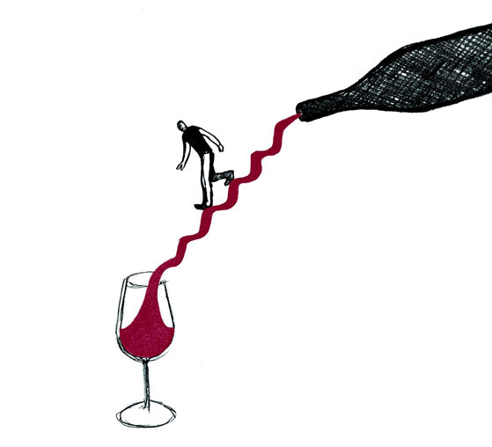

Red – Northern Italy
Cooperativa Valli Unite, Piedmont
2016 “Alessandrino” | Barbera, Dolcetto, Croatinia 26.50
Tenuta Grillo, Monferrato, Piedmont
2004 ”Pecoranera” | Freisa, Barbera, Dolcetto, Merlot 48.00
Fabio Gea, Barbaresco, Piedmont
2015 “Back Grin”| Grignolino 71.00
Barbacarlo, Commendatore Lino Maga, Lombardy
1994 ”Oltrepó Pavese DOC” | Croatina, Uva Rara, Ughetta 99.00 ArPePe, Sassella, Lombardy
2015 “Rosso di Valtellina”| Nebbiolo 55.00
2007 Sassella “Ultimi Raggi Riserva”| Nebbiolo 110.00
Monteforche, Alfonso Soranzo, Colli Euganei, Veneto
2016 “Lo Sfuso di Collina“| Cabernet Franc 32.00
La Biancara, Angiolino Maule, Veneto
2015 “Masieri Rosso“| Merlot, Tai Rosso, Cabernet Sauvignon 35.00
AA Elisabetta Foradori, Trentino
2013 Vigneti Delle Dolomiti IGT “Sgarzon” | Teroldego 70.00
Skerlj, Matej Skerlj, Carso, Friuli
2012 ”Terrano”| Terrano 56.00

Red – Central Italy
Az.Agr. La Stoppa, Elena Pantaleoni, Emilia-Romagna
2006 “Macchiona” | Barbera, Bonarda 54.00
Orsi San Vito, Federico Orsi, Emilia-Romagna, Italy
NV “Posca Rossa” | Sangiovese, Barbera, Negretto, Cabernet & more… 45.00
Le Coste, Gianmarco Antonuzzi & Clementine Bouveron, Gradoli, Lazio
2013 “Rosso” | Greghetto 58.00
2012 “Rosso” | Greghetto 58.00
2011 “Rosso” | Greghetto 59.00
Massa Vecchia, Maremma, Francesca Sfrondrini, Tuscany
2015 “IGT” | Sangiovese 84.00
Pian dell’Orino, Montalcino, Tuscany
2011 Brunello di Montalcino “Vigneti del Versante”| Sangiovese Grosso 110.00
Podera Le Boncie, Giovanna Morganti, Chianti, Tuscany
2015 “Cinque” | Sangiovese, Canaiolo 42.50
2013 “Le Trame” | Sangiovese 64.50
Fabbrica di San Martino, Giuseppe Ferrua, Colline Lucchesi, Tuscany
2013 “Rosso” | Sangiovese, Colorino, Canaiolo 55.00
Macea, Cipriano & Antonio Barsanti, Tuscany, Italy
2014 IGT “Pinot Nero” | Pinot Nero 68.00

Red – Southern Italy & Sicily
Cantina Giardino, Antonio & Daniela De Gruttola, Campania
2012 “Le Fole” | Aglianico 50.00
2008 “Nude” | Aglianico 74.00
L’Acino, Antonello Canonico, Dino Briglio & Emilio di Ciann, Calabria
2016 “Chora Rosso“| Magliocco, Guarnaccia 41.00
Frank Cornelissen Mt. Etna, Sicily
2014 ”Rosso del Contadino”| Nerello Mascalese 56.00
2015 ”Munjebel” | Nerello Mascalese 79.00

Red – Spain
Bernabe Navarro, Rafa Bernabe, Alicante
2016 “Tragolargo”| Monastrell 24.00
2016 “Casa Balaguer”| Monastrell, Syrah, Merlot, Tempranillo, Cabernet 37.00
Escoda-Sanahuja, Joan Ramon Escoda & Carmen Sanahuja, Catalunya
2013 “Nas del Gegant” | Garnatxa, Samso, Cabernet Franc, Merlot 42.00
2007 “Les Paradetes” | Garnatxa, Samso, Sumoll 57.00
2007 “Coll del Sabater” | Cabernet Franc, Merlot 58.00

Red – New World
A Los Viñateros Bravos, Leonardo Erazo, Itata Valley, Chile
2015 “Volcánico” | País 33.00
Tom Shobbrook, Barossa Valley, S. Australia
2016 “Cider” | Mouvèdre & Pears 45.00
Lucy Margaux Adelaide Hills, S. Australia
2015 “Wildman” | Pinot Noir 54.00
Jauma, James Erskine, McLaren Vale, S. Australia
2015 “Grampant” | Grenache 55.00
Patrick Sullivan, Victoria, Australia
2016 “Jumpin’ Juice” | Pinot Noir, Pinot Gris 46.00
Castagna, Julien Castagna, Beechworth, Australia
2013 “Adam’s Rib” | Nebbiolo, Shiraz 64.00
Felton Road, Central Otago, New Zealand
2013 “Bannockburn” | Pinot Noir 60.00
Ruth Lewandowski, Evan Lewandowski, Utah, USA
2016 “Feints” | Arneis, Dolcetto, Nebbiolo, Barbera 51.00
Ambyth Estate, Phillip & Marty Morwood-Hart, Paso Robles, California USA
2011 “Mourvèdre” | Mourvèdre 88.00

